## MINI PROJECT REPORT

ON

**MINNAL: Connecting Lines**

Submitted by

**ALLWINA ANNA SOY JOSE (SJC20CS021)**

**ALPHY GEORGE (SJC20CS023)**

**ANITA AUGUSTINE (SJC19CS029)**

**ANITTA SIBY (SJC19CS031)**

to

the A P J Abdul Kalam Technological University

in partial fulfillment of the requirements for the award of the degree

of

Bachelor of Technology

in

***Computer Science and Engineering***



**DEPARTMENT OF COMPUTER SCIENCE AND ENGINEERING ST. JOSEPH’S COLLEGE OF ENGINEERING AND TECHNOLOGY**

**PALAI JULY :: 2023**

## DECLARATION

I undersigned hereby declare that the mini project report on “Minnal: Connecting Lines” submitted for partial fulfillment of the requirements for the award of degree of Bachelor of Technology of the APJ Abdul Kalam Technological University, Kerala is a bonafide work done by me under supervision of Prof. Maria Yesudas, Assistant Professor, Dept of CSE. This submission represents my ideas in my own words and where ideas and words of others have been included. I have adequately and accurately cited and referenced the original sources. I also declare that I have adhered to ethics of academic honesty and integrity and have not misrepresented or fabricated any data or idea or fact or source in my submission. I understand that any violation of the above will be a course for disciplinary action by the institute and/or the University and can also evoke panel action from the sources which have thus not been properly cited or from whom proper permission has not been obtained. This report has not been previously formed the basis for the award of any degree, diploma or similar title of any other University.

**Name and Signature of Student**

**ALLWINA ANNA SOY JOSE (SJC20CS021)**

**ALPHY GEORGE (SJC20CS023)**

**ANITA AUGUSTINE (SJC20CS029)**

**ANITTA SIBY (SJC20CS031)**

Place: Choondacherry Date: 24-06-2023

## ST. JOSEPH’S COLLEGE OF ENGINEERING AND TECHNOLOGY,

## PALAI



**DEPARTMENT OF COMPUTER SCIENCE AND ENGINEERING**

**CERTIFICATE**

This is to certify that the report entitled **Minnal: Connecting Lines** submitted by **ALLWINA ANNA SOY JOSE (SJC20CS021), ALPHY GEORGE (SJC20CS023), ANITA AUGUSTINE (SJC20CS029), ANITTA SIBY(SJC20CS031)** to the APJ Abdul Kalam Technological University in partial fulfillment of the requirements for the award of the Degree of Bachelor of Technology in Computer Science and Engineering is a bonafide record of the mini project work carried out by them under my guidance and supervision.

**Mini Project Guide Mini Project Coordinator**

Prof. Maria Yesudas, Prof. Mereen Thomas

Assistant Professor, Assistant Professor,

Dept. of CSE Dept. of CSE

**Head of the department**

Prof. (Dr.) Joby P.P.,

Place: Choondacherry Professor & Head,

Date: 24-06-2023 Dept. of CSE

## ACKNOWLEDGEMENT

The success and final outcome of this mini project required a lot of guidance and assistance from many people and I am extremely privileged to have got this all along the completion of this project. All that I have done is only due to such supervision and assistance and I would not forget to thank them.

I respect and thank the **management** of **St. Joseph’s College of Engineering and Technology** for providing me an opportunity and platform for doing the project work.

I am extremely thankful to our beloved **Principal, Dr. V. P Devassia** for providing such nice support and facilities to carry out this project.

I am extremely indebted to **Dr. Joby P.P,** Professor & Head, Department of Computer Science and Engineering for his valuable suggestions and encouragement during the course of this project work.

I would like to express my gratitude to my project coordinator Prof. Mereen Thomas**,** Asst. Professor, Department of Computer Science and Engineering for her valuable suggestions and guidelines throughout the period of this project work. Her contributions and technical support in preparing this report are greatly acknowledged.

I owe my deep gratitude to my project guide Prof. Maria Yesudas**,** Asst. Professor, Department of Computer Science and Engineering who took keen interest in this project and guided me all along, till the completion of this project work by providing all the necessary information for developing a good system.

I am thankful and fortunate enough to get constant encouragement, support and guidance from all the staff members of the department of Computer Science and Engineering, which helped me in successfully completing my mini project work.

## ABSTRACT

**Problem Statement:** Electricity consumers face a lot of problems regarding electricity in their day-to-day life. Among all these problems the inability to connect to the electricity board due to busy network lines is a major concern.

The existing solutions are KSEB web self-service, Helpline numbers and WhatsApp bots. The issues pertaining to these solutions are as follows: 1) The online form needs to be filled from scratch each time the complaint has to be registered. 2) The helpline numbers are mostly busy and may also suffer from lack of network services. 3) There is a limit to add members in WhatsApp groups. Preferable solution is to make a system where the data about the consumer will be saved only once and a single click can connect them to the electricity board authorities. The project acts as an intermediate between electricity consumers and the electricity board authorities. The project mainly deals with the servicing requests of transformers in case of any compliant. There will be login for both consumers and board authorities. Details of consumer such as consumer number, post number, transformer number will be accepted at the time of registration. The features include notification by Board authorities in case of power outage, reporting the problems faced by consumers due to post or transformer complaint, intensity or measure of the problem is sorted according to priority and displaying the problem and address on the authority frontend.

**Keywords:** KSEB, Consumer, Board

## CONTENT

MINI PROJECT REPORT 1

DECLARATION 2

ST. JOSEPH’S COLLEGE OF ENGINEERING AND TECHNOLOGY, 3

PALAI 3

ACKNOWLEDGEMENT 4

ABSTRACT 5

CONTENT 6

LIST OF ABBREVIATIONS 9

CHAPTER 1 10

INTRODUCTION 10

1.1 Problem Statement 10

1.2 Objectives and Scope 11

CHAPTER 2 12

LITERATURE SURVEY 12

2.1 Electronic Complaint Management System for Municipal Corporation 12

2.2 AI-Driven Complaint Management System 13

2.3 Electronic-Customer Complaint Management System (E-CCMS) – a Generic Approach 13

CHAPTER 3 14

SOFTWARE REQUIREMENT SPECIFICATION 14

3.1 AUTHENTICATION AND AUTHORIZATION 14

3.2 USER MODULES 14

CHAPTER 4 16

SYSTEM DESIGN 16

4.1 ACTIVITY DIAGRAM 16

4.2 ER DIAGRAM 18

4.3 USE CASE DIAGRAM 19

CHAPTER 5 20

SYSTEM IMPLEMENTATION 20

5.1 TECHNOLOGIES USED 20

5.1.1 FLUTTER 20

5.1.2 FIREBASE 20

CHAPTER 6 21

TESTING 21

6.1 VARIOUS TESTING METHODS 21

6.1.1 Unit Testing 21

6.1.2 Integration Testing 21

6.1.3 Functional Testing 21

6.1.4 Load Testing 21

6.2 TESTING 22

CHAPTER 7 23

RESULTS 23

7.1 FRONTEND 23

7.2 BACKEND 35

CONCLUSION 37

REFERENCES 38

**LIST OF FIGURES**

4.1 Activity Diagram

4.2 ER Diagram

4.3 Use Case Diagram

6.2.1 Login

6.2.2 Status Updation

7.1.1 Signup and Login

7.1.2 Admin Dashboard

7.1.3 Cart Dashboard

7.1.4 Payment Dashboard

7.1.5 Shipment Dashboard

7.2.1 Regristration

## LIST OF ABBREVIATIONS

|  |  |
| --- | --- |
| API | Application Programming Interface |
| KSEB | Kerala State Electricity Board |
| UML | Unified |
| ERD | Entity Relationship Diagram |
| UI | User Interface |
| QA | Quality Assurance |

## **CHAPTER 1**

## INTRODUCTION

App development is the process of creating software applications specifically designed for mobile devices. It involves various stages, starting with ideation and concept development, followed by design, coding, testing, and deployment.

During the development phase, developers use programming languages to write the code that brings the app to life, integrating features such as user interfaces, functionalities, and data management. Thorough testing is conducted to identify and fix any bugs or issues, ensuring the app functions properly and provides a seamless user experience.

Once the app is ready, it is deployed on app stores, making it available for users to download and install on their devices. Regular updates and maintenance are important to keep the app up-to-date, secure, and compatible with new devices and operating system versions.

App development requires a combination of technical skills, creativity, and an understanding of user needs. It is a constantly evolving field, with new technologies and trends shaping the development process. Successful app development relies on collaboration between developers, designers, testers, and project managers to deliver high-quality applications that meet user expectations and solve specific problems.

### 1.1 Problem **Statement**

To address the problems faced by electricity consumers in connecting with the electricity board, several existing solutions have been implemented, including KSEB web self-service, helpline numbers, and WhatsApp bots. However, these solutions come with their own set of issues.

Firstly, the KSEB web self-service requires consumers to fill out an online form from scratch each time they need to register a complaint. This can be time-consuming and inconvenient, especially if consumers face frequent issues or need to provide detailed information.

Secondly, helpline numbers often suffer from being constantly busy, making it difficult for consumers to reach customer support representatives. Additionally, these helpline numbers may also encounter network connectivity issues, further hindering the ability to connect and report problems effectively.

Lastly, while WhatsApp bots provide a convenient platform for communication, there is a limit to the number of members that can be added to WhatsApp groups. This can be problematic if a significant number of consumers need to join the group to receive updates and communicate with the electricity board.

To improve the current situation, it would be beneficial to explore alternative solutions that offer a more streamlined and efficient process for consumers to report electricity-related issues. This could include the development of a dedicated mobile application that allows consumers to easily register complaints, track progress, and receive updates. Implementing a robust ticketing system or utilizing AI-powered chatbots could also help in managing and resolving consumer complaints effectively while reducing the burden on helpline numbers.

### 1.2 Objectives and Scope

"Connecting Lines"

It is a platform designed to address the challenges faced by electricity consumers when connecting with the authorities regarding complaints or issues. Often, busy network lines make it difficult for consumers to reach the board authorities in a timely manner. This project aims to simplify the process by providing a one-click connection to the board.

One of the common issues consumers face when filing complaints online is the need to fill out the form from scratch each time. This project streamlines the process by allowing consumers to enter their details once, which are then saved for future reference. This saves time and avoids repetitive data entry.

Another advantage of "Connecting Lines" is its scalability. Unlike WhatsApp groups with member limitations, there is no limit to adding consumers to this application. This ensures that all consumers can join and communicate effectively with the board authorities.

By providing an organized and efficient way of connecting consumers with the board, "Minnal: Connecting Lines" aims to improve the overall experience and ensure that consumer complaints are effectively addressed.

## CHAPTER 2

## LITERATURE SURVEY

The literature survey focuses on exploring the use of complaint management apps as interfaces between electricity consumers and electricity boards, specifically focusing on the Kerala State Electricity Board (KSEB). With the increasing demand for electricity, it is crucial to have an effective system in place that allows consumers to submit and track complaints while enabling KSEB to address complaints in a timely manner. The survey explores the features and functionalities of the complaint management app, highlighting its user-friendly interface and seamless connectivity with KSEB. By allowing consumers to report complaints with just a single click and storing their personal details in the database, the app eliminates the need for repetitive data entry. Consumers can easily monitor the progress of their complaints and stay updated on the resolution status. Furthermore, the app enables KSEB authorities to resolve complaints effectively by displaying the number of affected consumers in specific areas and evaluating the validity and severity of each complaint. This helps prioritize complaints and allocate resources accordingly, ensuring efficient resolution and customer satisfaction. Overall, the complaint management app acts as a bridge between electricity consumers and KSEB, facilitating effective communication, quick complaint resolution, and streamlined processes. By leveraging technology, the app aims to enhance the overall consumer experience and strengthen the relationship between consumers and electricity boards.

### 2.1 Electronic Complaint Management System for Municipal Corporation

This project mainly focuses on sanitation and development of a municipal corporation. The people who belong to the municipal corporation are provided with an opportunity of raising a complaint regarding any issue that take place in their locality. The issues are garbage management, water supply, electricity management, road repairs or layering of roads and threatening of animals.

Disadvantages:

* Site seems complex
* Limited to users of municipal corporation

### 2.2 AI-Driven Complaint Management System

This system can recognize grievances by identifying and commenting on each complaint that has been raised. The concern of citizens is treated according to the priority in this portal. That is a problem depending on the seriousness of the situation that will be prioritized.

Disadvantages:

* Do not display number of affected consumers in specific areas
* Limited scalability
* Priority of complaint is computed using sentiment analysis which may not be accurate

### 2.3 Electronic-Customer Complaint Management System (E-CCMS) – a Generic Approach

This system addresses the drawbacks of poor service quality and delivery in the complaining process of e-complaints. The advantage from this proposed model is the easy way of managing the Citizen’s complaints about what displeases them.

Disadvantages:

* Automated systems or algorithms for complaint management may not capture the full context of customer grievances.
* Customers may feel that their complaints are being treated impersonally or that their individual needs are not being properly addressed. This can result in a negative perception of the company or organization and may damage customer loyalty and long-term relationships.

## CHAPTER 3

## SOFTWARE REQUIREMENT SPECIFICATION

Divided into 2 parts:

* + - Authentication & Authorization
    - User modules

### 3.1 AUTHENTICATION AND AUTHORIZATION

Authentication is the process of recognizing a user’s identity. It is the mechanism of associating an incoming request with a set of identifying credentials. This platform includes a user account registration feature, which enables users to create an account within the system. In order to register a complaint, users are required to have an account and be logged into it. This feature ensures that the user's details are enlisted and stored in the database.

Additionally, the platform provides a separate login for KSEB (Kerala State Electricity Board) authorities. This login allows them to access the database and view consumer details such as location and the type of issue reported. By granting authorities access to this information, they can efficiently track and address consumer complaints.

This feature of user accounts and a separate login for authorities enhances the functionality and effectiveness of the platform. It facilitates a streamlined communication channel between consumers and the KSEB authorities, ensuring a smooth process for registering and resolving complaints.

### 3.2 USER MODULES

**Consumer:**

Input Requirements:

- Consumer number, post number, and transformer number for registration.

- Report button to send information about the issue.

- Primary details will be saved for future reference.

Output Requirements:

- Status of the reported issue.

- Display of alert messages sent by the Board.

**Board:**

Input Requirements:

- Ability to send alert messages to consumers.

- Marking the status of resolved issues.

Output Requirements:

- Display of all addresses with reported issues by consumers.

For the consumer, the input requirements include providing essential details like consumer number, post number, and transformer number during the registration process. These details will be stored for future reference. Additionally, there should be a report button that allows consumers to submit information about their issues.

The output requirements for consumers are to receive updates on the status of their reported issues. They should be able to see the progress or resolution of their complaints. Furthermore, the system should display any alert messages sent by the Board, providing relevant information or instructions to the consumers.

On the Board side, the input requirements involve the ability to send alert messages to consumers. This could be for important notifications or updates related to electricity issues. The Board should also have the capability to mark the status of resolved issues in the system.

The output requirements for the Board include displaying the addresses or locations where issues have been reported by consumers. This provides an overview of the areas affected by problems and helps the Board to efficiently prioritize and address the reported issues.

## CHAPTER 4

## SYSTEM DESIGN

### 4.1 ACTIVITY DIAGRAM

Activity diagram is another important behavioral diagram in UML diagram to describe dynamic aspects of the system. Activity diagram is essentially an advanced version of flow chart that models the flow from one activity to another activity. Activity diagrams can be regarded as a form of a structured flowchart combined with a traditional data flow diagram. Typical flowchart techniques lack constructs for expressing concurrency. However, the join and split symbols in activity diagrams only resolve this for simple cases; the meaning of the model is not clear when they are arbitrarily combined with decisions or loops.

There are two activity diagrams. One for Consumer and another for Board. The below diagrams show the activities while the Consumer and Board uses the app.

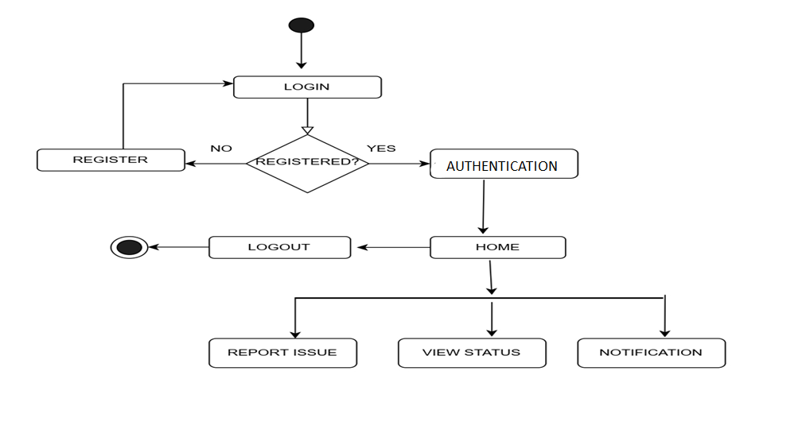**CONSUMER**

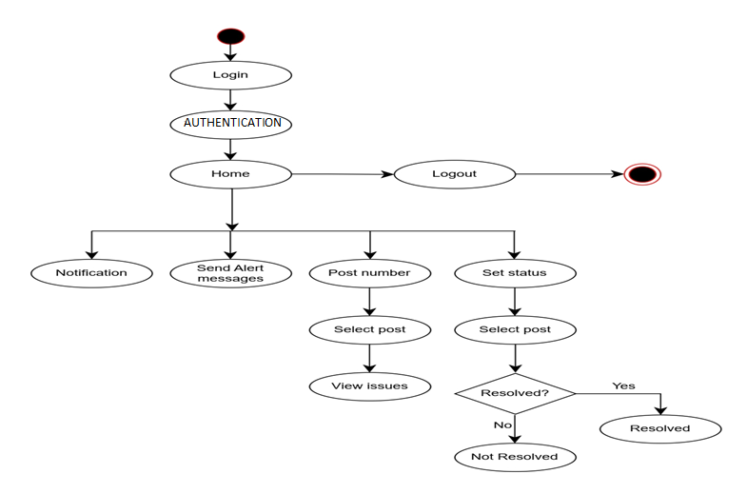**BOARD**

### 4.2 ER DIAGRAM

ER Diagram stands for Entity Relationship Diagram, also known as ERD is a diagram that displays the relationship of entity sets stored in a database. In other words, ER diagrams help to explain the logical structure of databases. ER diagrams are created based on three basic concepts: entities, attributes and relationships. ER Diagrams contain different symbols that use rectangles to represent entities, ovals to define attributes and diamond shapes to represent relationships.

From the below ER Diagram, the attributes of various entities such as consumers board, collected database, login, complaint and notification can be understood along with their relationships.

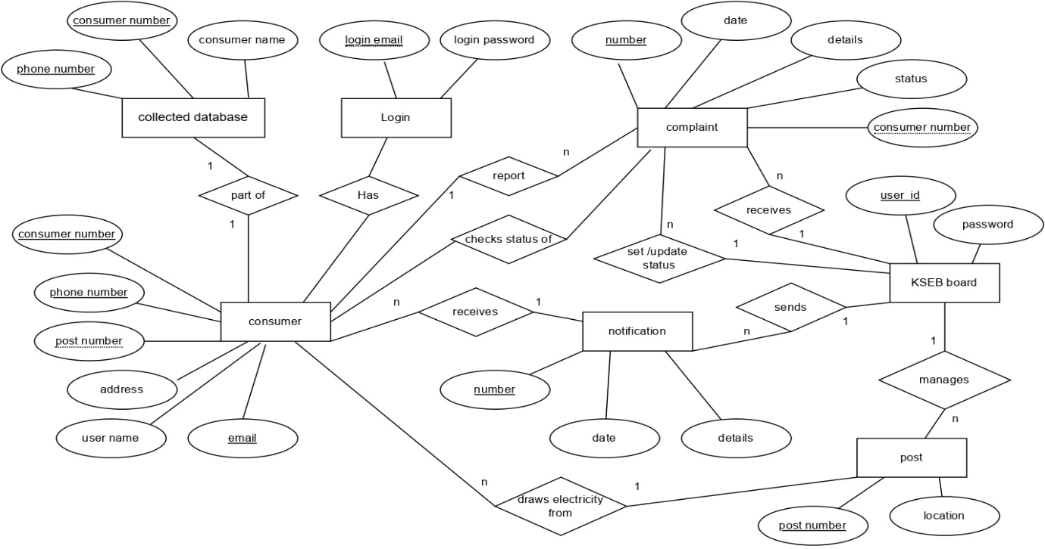

### 4.3 USE CASE DIAGRAM

A use case diagram is a graphical depiction of a user's possible interactions with a system. A use case diagram shows various use cases and different types of users the system has and will often be accompanied by other types of diagrams as well. The use cases are represented by either circles or ellipses. The actors are often shown as stick figures.

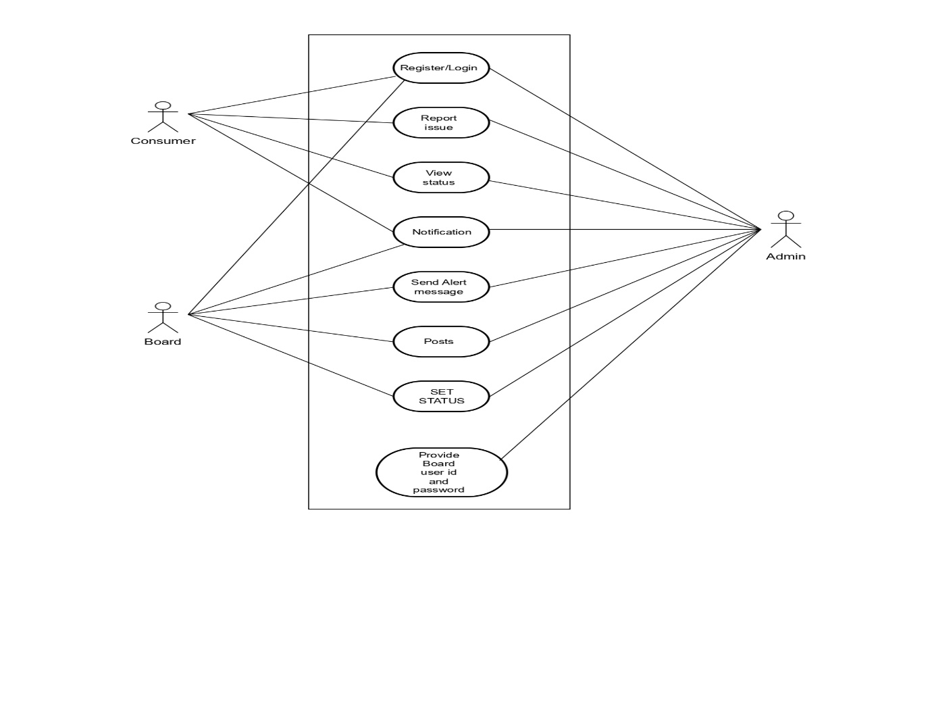From the below diagram, we can get that the consumer can Register / Login, Report Issue, View Status and view Notifications. Board can Send alert messages, View status, Posts and View Notifications.

## CHAPTER 5

## SYSTEM IMPLEMENTATION

### 5.1 TECHNOLOGIES USED

### 5.1.1 FLUTTER

Flutter is an open-source UI toolkit developed by Google for building high-quality native applications across multiple platforms. With Flutter, developers can write a single codebase that runs on iOS, Android, web, and desktop platforms, saving time and effort.

Using the Dart programming language, Flutter provides a rich set of customizable widgets that enable developers to create visually appealing and responsive user interfaces. It offers a "hot reload" feature, allowing developers to instantly see the changes made to the code without restarting the app, leading to faster development cycles and iterative design.

One of the key benefits of Flutter is its high performance. Flutter apps are compiled to native machine code, resulting in smooth animations, fast rendering, and excellent overall performance. The framework also provides access to platform-specific APIs and features, ensuring a native-like experience on each platform.

Flutter has a growing community and ecosystem, with a wide range of packages and libraries available for additional functionality and integration with other services. The framework is suitable for both small-scale projects and large-scale applications, making it popular among developers for its versatility, productivity, and ability to deliver beautiful and performant applications across multiple platforms.

### 5.1.2 FIREBASE

Firebase is a popular mobile and web development platform provided by Google. It offers a comprehensive set of tools and services that developers can leverage to build robust and scalable applications.

Firebase provides features such as real-time database, authentication, cloud storage, and hosting. The real-time database enables developers to synchronize and store data across multiple clients in real-time. The authentication service offers easy integration of secure user authentication using various authentication providers.

Firebase's cloud storage allows developers to store and retrieve files in the cloud, eliminating the need for managing complex server infrastructure. The hosting service enables seamless deployment and hosting of web applications.

Additionally, Firebase offers services like cloud functions, performance monitoring, remote configuration, and analytics, empowering developers to enhance app functionality, monitor performance, and gain insights into user behavior.

Overall, Firebase simplifies the development process, provides scalable backend services, and enables developers to build powerful applications with ease.

## CHAPTER 6

## TESTING

### 6.1 VARIOUS TESTING METHODS

### 6.1.1 Unit Testing

Unit testing is a software development process in which the smallest testable parts of an application, called units, are individually and independently scrutinized for proper operation. This testing methodology is done during the development process by the software developers and sometimes QA staff. The main objective of unit testing is to isolate written code to test and determine if it works as intended.

### 6.1.2 Integration Testing

Integration Testing is defined as a type of testing where software modules are integrated logically and tested as a group. A typical software project consists of multiple software modules, coded by different programmers. The purpose of this level of testing is to expose defects in the interaction between these software modules when they are integrated.

### 6.1.3 Functional Testing

Functional testing is a type of testing that seeks to establish whether each application feature works as per the software requirements. Each function is compared to the corresponding requirement to ascertain whether its output is consistent with the end user’s expectations. The testing is done by providing sample inputs, capturing resulting outputs, and verifying that actual outputs are the same as expected outputs.

### 6.1.4 Load Testing

Load testing is a type of performance testing that simulates a real-world load on any software, application, or website. Without it, your application could fail miserably in real- world conditions. That’s why we build tools like Retrace to help you monitor application performance and fix bugs before your code ever gets to production. Load testing examines how the system behaves during normal and high loads and determines if a system, piece of software, or computing device can handle high loads given a high demand of end-users. This tool is typically applied when a software development project nears completion.

### 6.2 TESTING

## CHAPTER 7

## RESULTS

The system architecture consists of a mobile application which is the front end that is developed using Flutter. The Backend of this application is built using Firebase queries. The live server is deployed using the Firebase.

### 7.1 FRONTEND

The user can login as Board or Consumer. As a Consumer he can utilize various features such a Report Issue, View Status, Notification. As Board, he can utilize various features such as Notification, Send Alert Messages, Poles and Set Status.

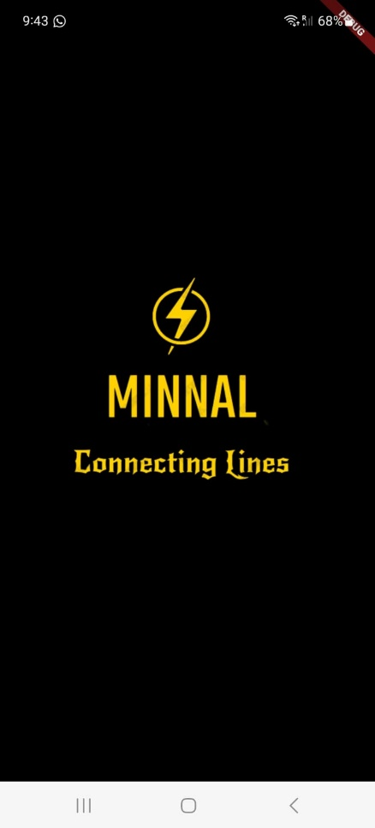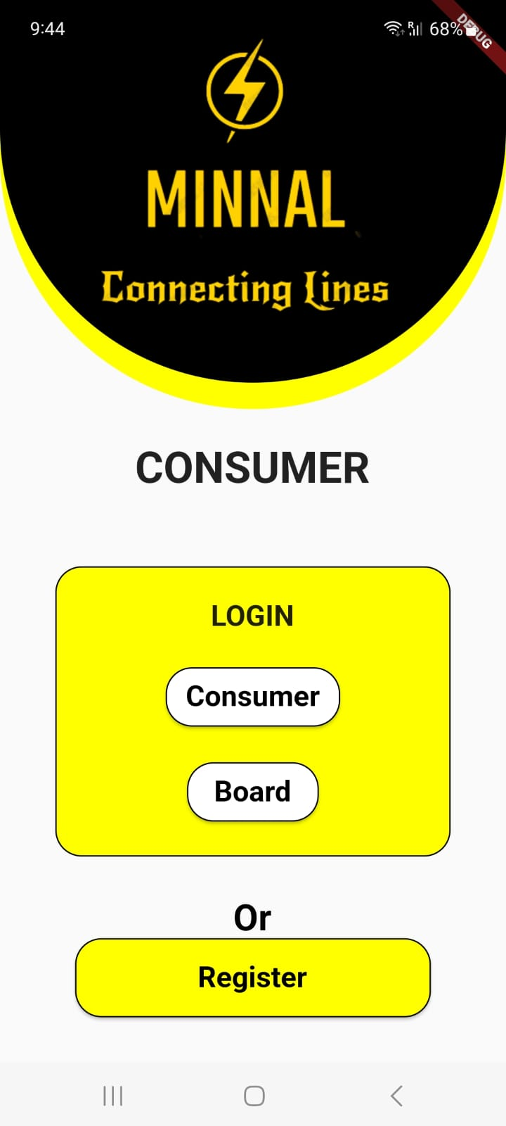

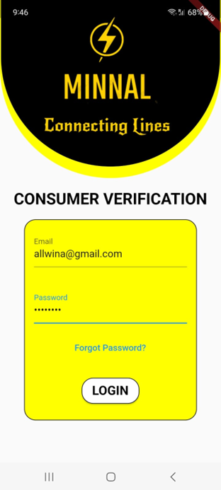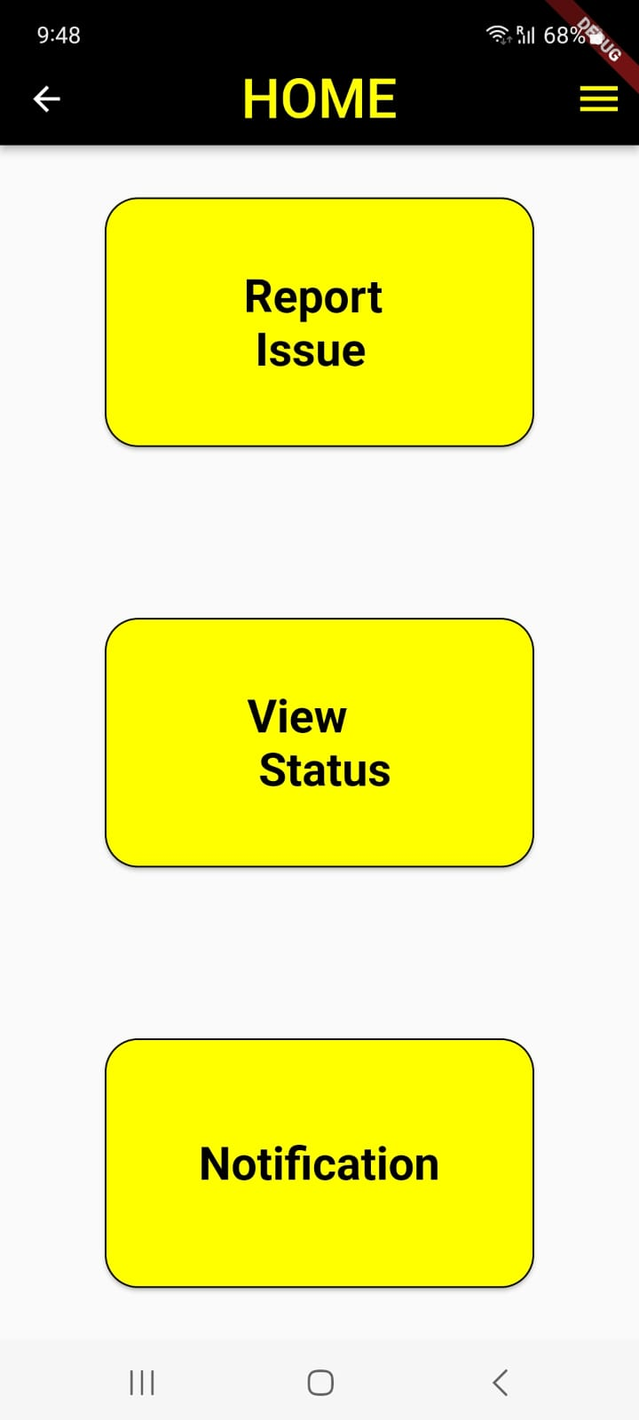

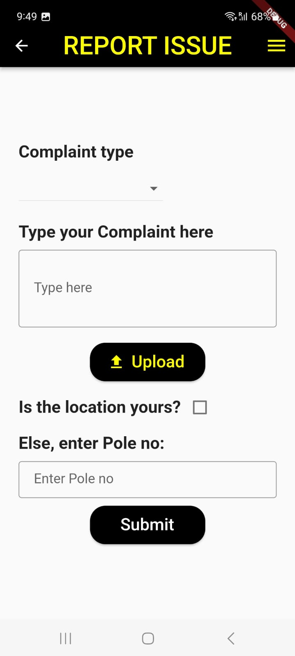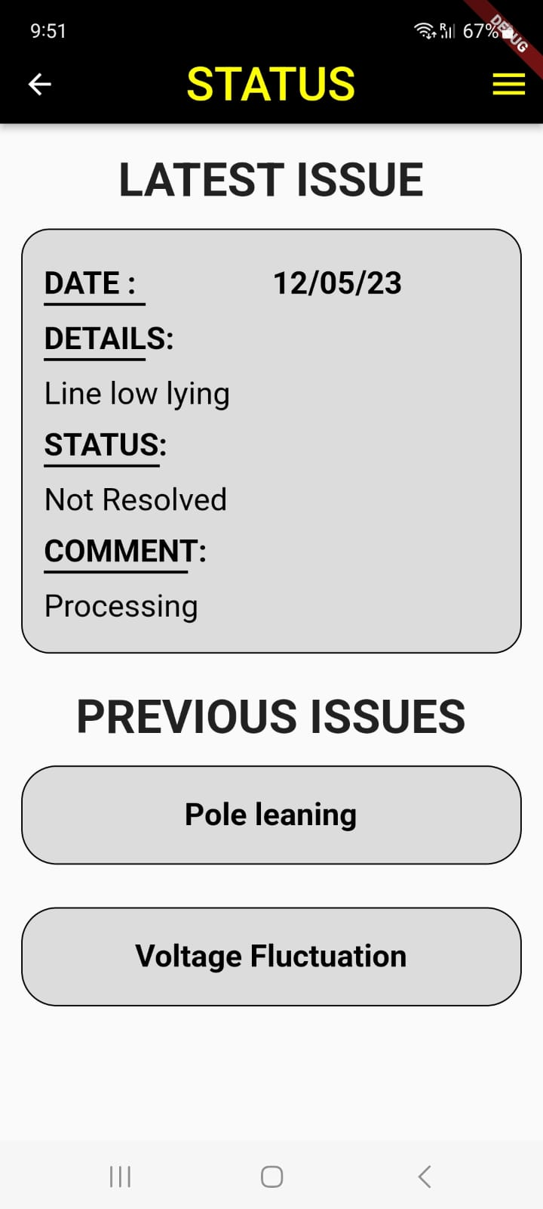

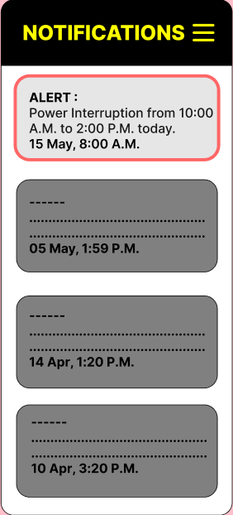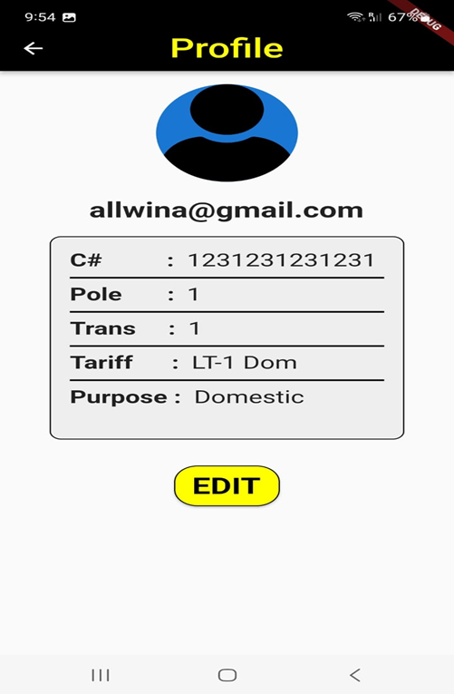

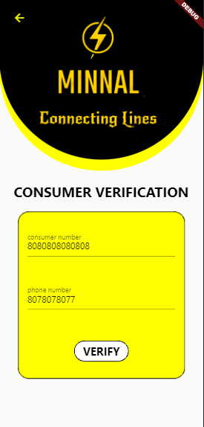

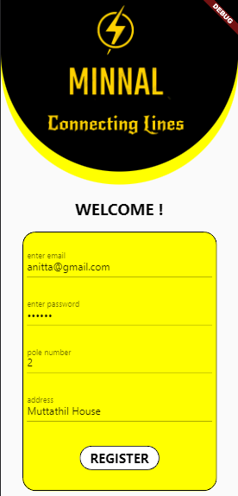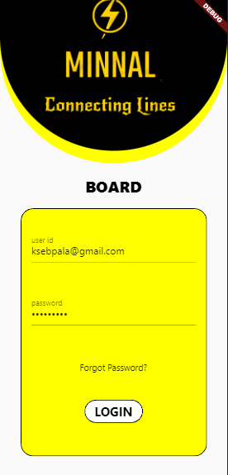

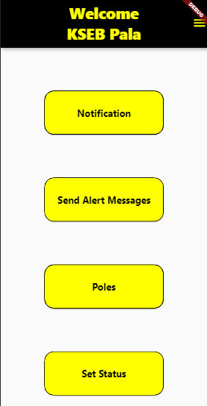

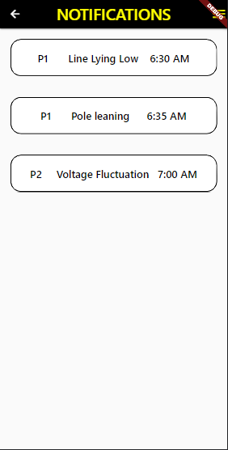

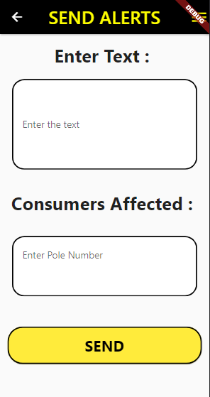

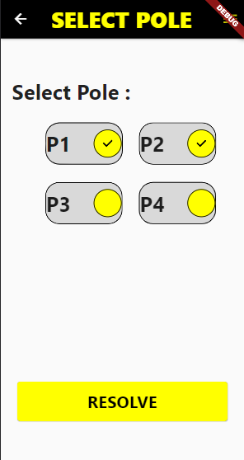

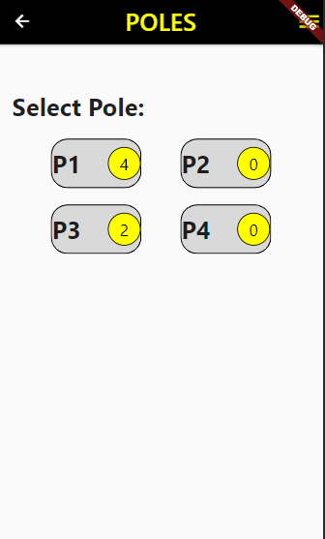

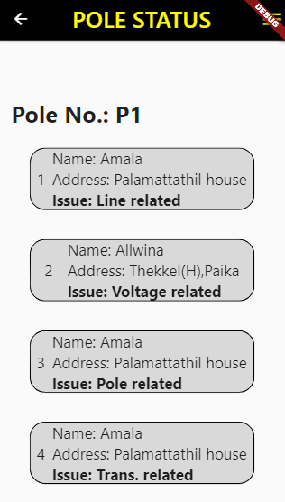

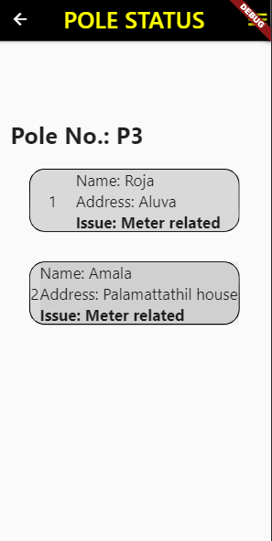

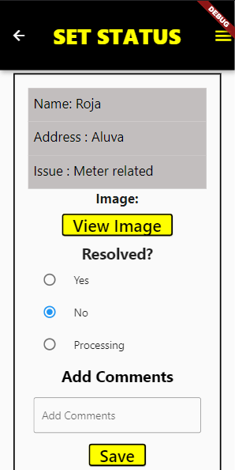

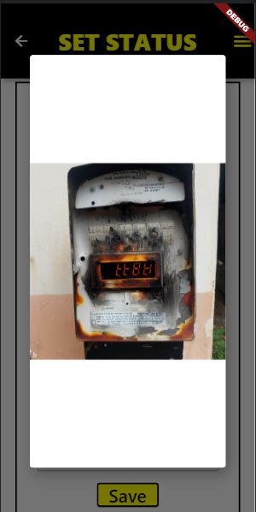

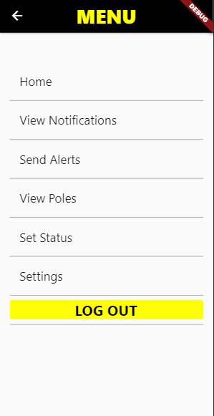

### 7.2 BACKEND

The backend can be used to store the details of consumers and Board such as login credentials, data shared between each other, images, consumer details, board details etc.

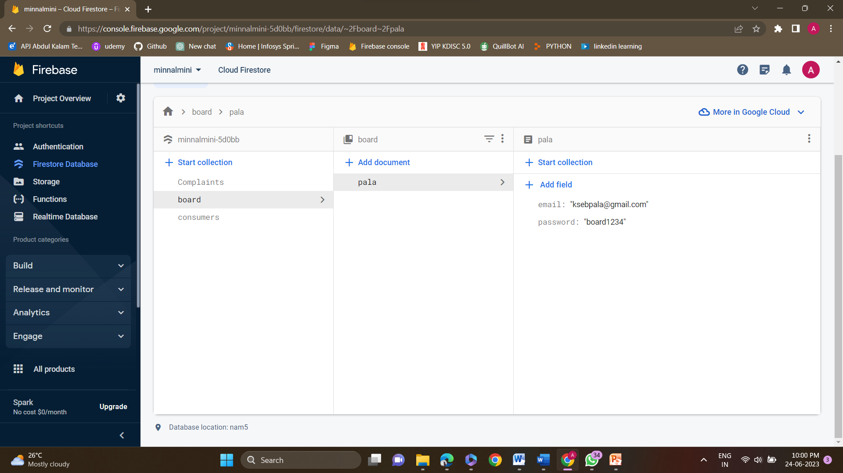

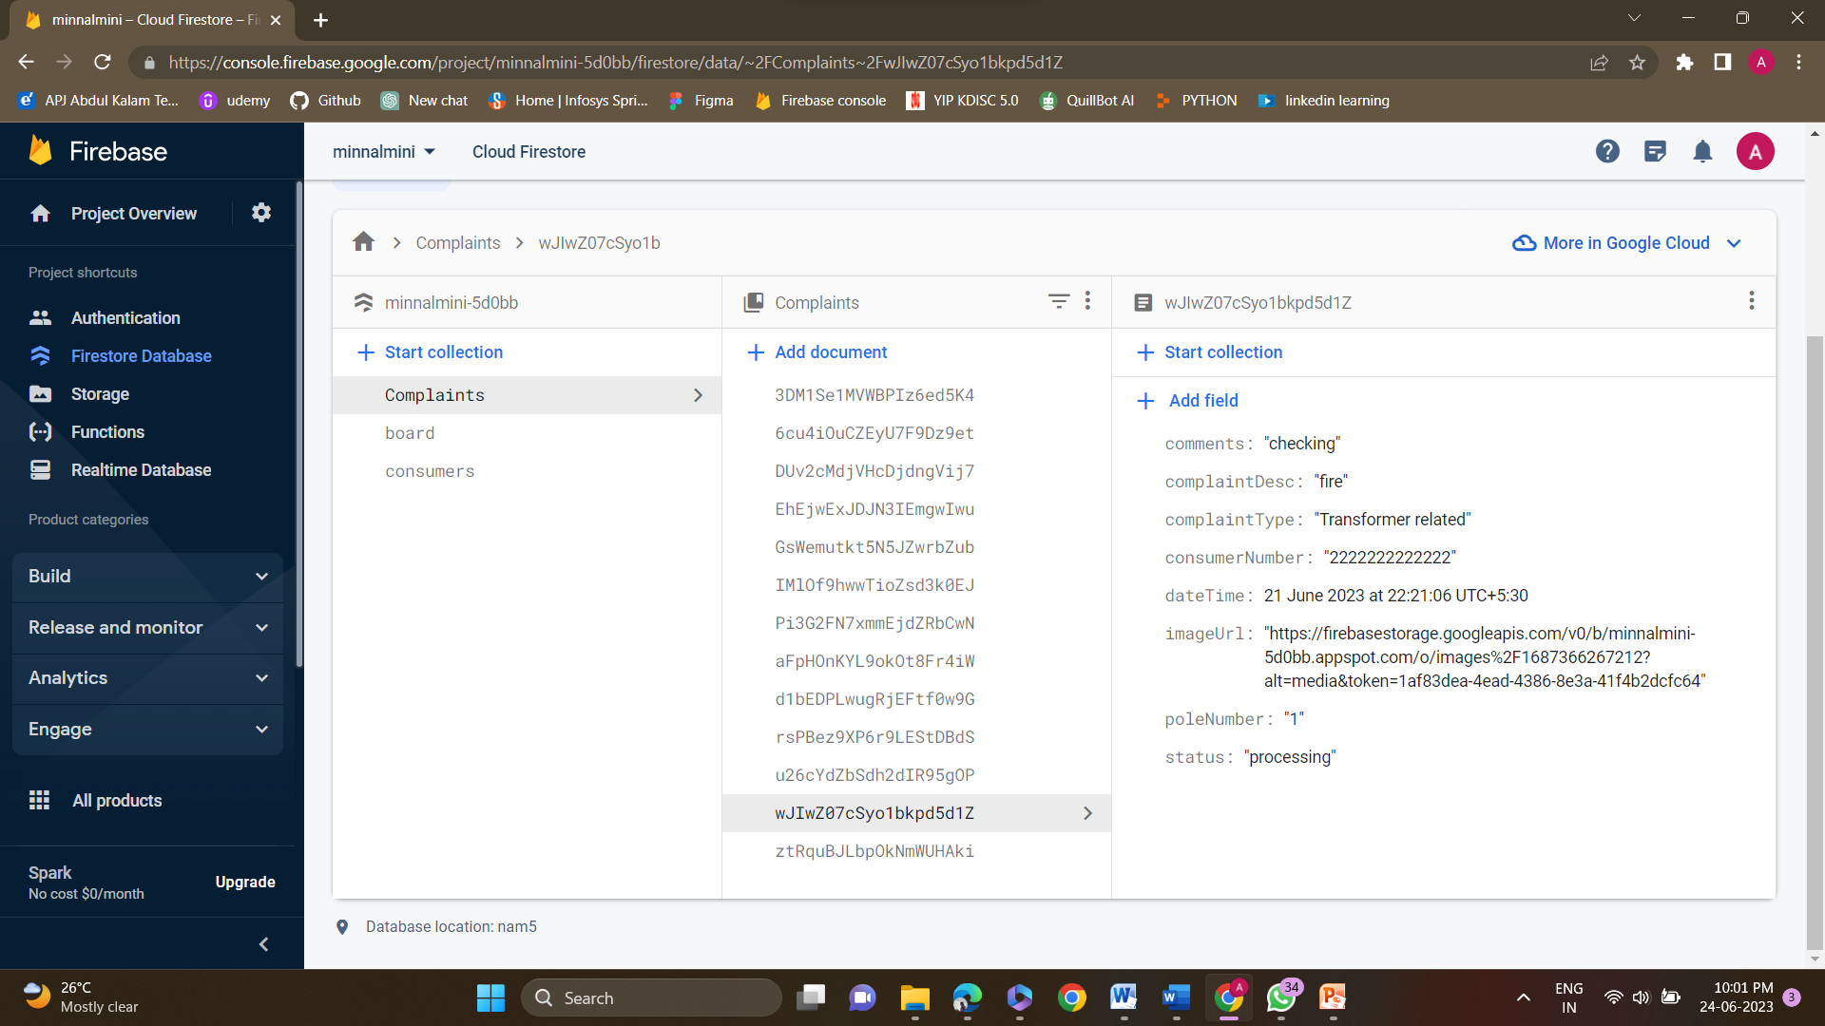

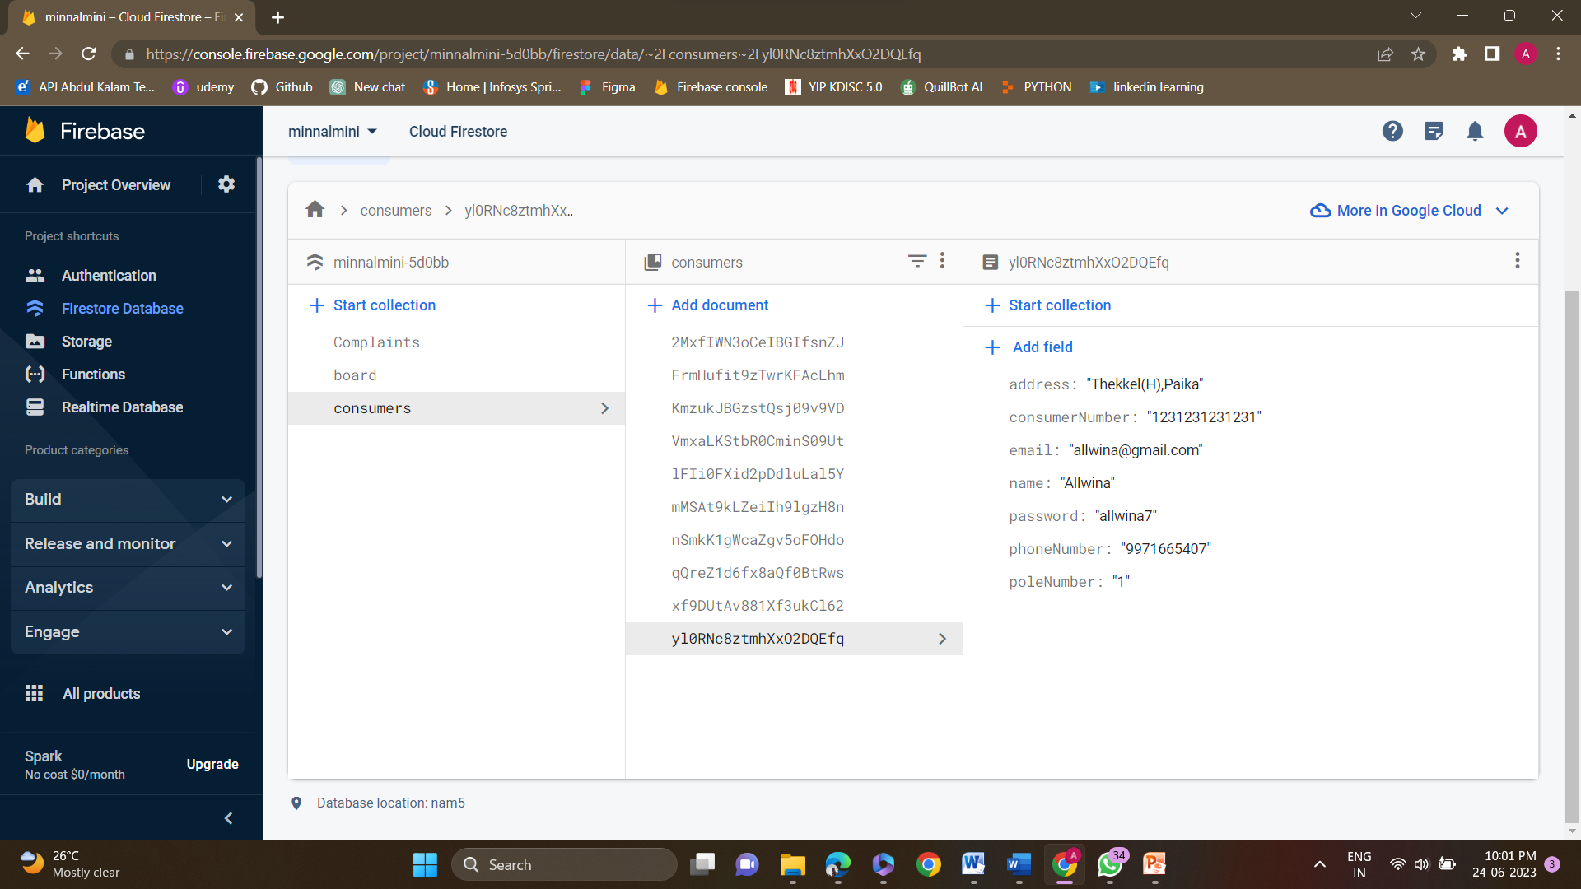

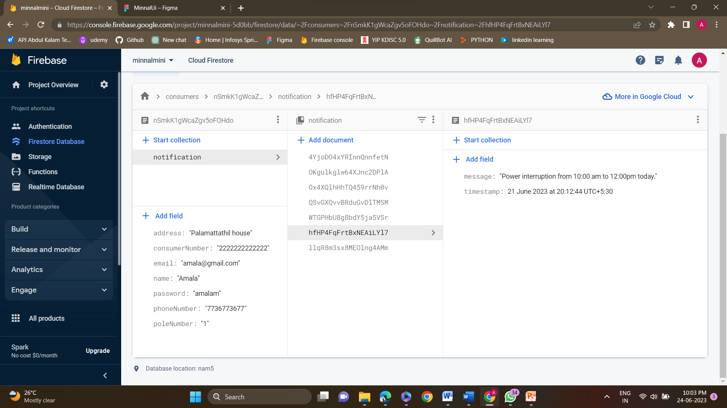

## CONCLUSION

Technology has revolutionized the way we live, work and interact with the world around us.

It has made our lives better and easy. Such is the development of MINNAL: Connecting Lines, a project that came into existence due the lack of interaction between Board and Consumer. The project aims at providing portability, a single touch to connect the consumers with board. All the problems that led to its development has been taken into consideration and solved in the best way possible.

The Consumers can now utilize the features such as Report Issue, View status and notification.

The board can now easily understand where the issue has raised, which pole has the most issues, which consumer is facing the problem etc. The app is a better way of connecting. The user friendly UI and working makes it best for the users. All the functional and non functional requirements have been met successfully.

## REFERENCES

* + - 1. Fornell C., & Westbrook A. Robert, “The Vicious Circle of Consumer Complaints”, journal of Marketing, (summer)(1984), 68-78.
      2. "Sentimental Analysis ": Analysis and application: Sentiment Analysis: Concept, Analysis and Applications | by Shashank Gupta | Towards Data Science
      3. Flutter: Flutter, "Flutter Documentation," [Online]. Available: https://flutter.dev/docs. [Accessed: June 24, 2023].
      4. Stack Overflow: Stack Overflow, "Stack Overflow - Where Developers Learn, Share, and Build Careers," [Online]. Available: https://stackoverflow.com. [Accessed: June 24, 2023]
      5. GitHub: GitHub, "GitHub - Where the World Builds Software," [Online]. Available: https://github.com. [Accessed: June 25, 2023].
      6. E. Windmill, "Flutter in Action," Manning Publications, 2020.